|  |  |  |
| --- | --- | --- |
| Description: Logo | Description: KOTM SPOT FLAT RGB  **Newton Moore Senior High School**  **Year 12 Physics ATAR Unit 3 & 4**  **2019**  **Task 2: Test – Gravity 1** | **Result:**  **/ 44** |

|  |  |  |  |
| --- | --- | --- | --- |
| Student’s name: |  | Total marks: | 44 |
| Teacher’s name: | Kevin Lloyd | Weighting: | 3% |
| Assessment type: | Test | Time allocated:  Due date: | Term 1 week 4 |

1. a) Calculate the mass of a 75 kg person on the moon. (Moon’s gravity is about 1.6 ms-2)

(1 Mark)

b) List reasons for differences in the forces of gravity on different objects. (2 Marks)

________________________________________________________________________________________________________________________________________________________________________________________________________________________________________________________________________________________________________________________________

1. The planet Neptune has a mass of about 17 times that of Earth and a radius of 22.7 x 103 km. [WATP 2008]

(a) Calculate the acceleration due to gravity at the surface of Neptune. (3 Mark)

(b) What would be the weight, on the surface of Neptune, of a landing module whose mass is 40 kg? (2 Marks)

(c) What would be the gravitational field at the midpoint between, and due to two identical planets? Explain your answer using a diagram. (2 Marks)

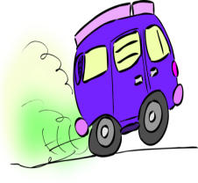

1. A large van with a mass of 2.50 x 103 kg is parked at the top of a hill that is inclined at 47.0o to the vertical. The brakes fail. Calculate the force that is now pulling the truck down the hill? (4 Marks)
2. 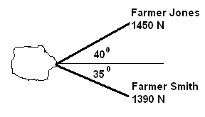In order to pull a large rock out of the way, Farmer Jones has asked for help. The rock is supplying a retarding (friction) force of 2.16 x 103 N. The diagram shows the situation and supplied forces. Will they be able to pull the rock out? You must show calculations to justify your answer. (3 marks)



1. A kangaroo jumps to a vertical height of 2.80 m. How long was it in the air before returning to earth? (3 Marks)
2. A helicopter approaching a bush fire horizontally at a speed of 23.0 ms-1 must release the water no closer than 180 m from the fire and then turn quickly away to avoid flying over the fire. What is the minimum height that this helicopter can fly to ensure that the water reaches the fire? (4 Marks)
3. Bruce kicks a ball at an angle of 30.00 from the horizontal with an initial speed of 15.0 ms-1. Find how far the ball travels horizontally before hitting the ground. (4 Marks)
4. A projectile is thrown up from the edge of a 40m high cliff with a velocity of 35.1 ms-1 at 30 degrees to the horizontal. (4 Marks)

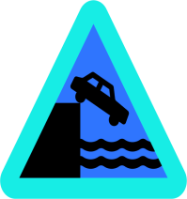

1. Isabella has got her football stuck in a tree. She throws her shoe at the tree to try and dislodge the football. The shoe is launched at an angle θ to the horizontal. The shoe reaches its maximum height of 5.10 m above the ground, continues and then gets stuck in the tree at a horizontal distance of 4.00 m in front of her. The flight time from the launch position to arriving at the tree was 0.950 s. [WATP 2015]

Maximum height = 5.10 m

Range = 4.00 m

Isabella releases shoe at 1.90 m above ground

θ

Initial launch speed u

1. Calculate the initial velocity of the shoe. Note that this is a vector quantity. (5 marks)
2. Calculate the height above ground of the shoe when it became stuck in the tree. If you could not solve for the initial velocity u then use a value of 8.97 m s-1 at 62.0° above the horizontal. (3 marks)

1. The kinetic energy of the shoe after 0.450 seconds of flight was 9.57 J. Calculate the mass of the shoe.

(4 marks)

END OF TEST